Product Branding Style Guide
Business Internet Banking
Standard Package

November, 2009

Please fill in please fill in the box below and forward this completed style guide to your svc mgr

Client Name: Hamilton Federal Bank | Date: 2/23/12
Client ID: 3121 | Title: Vice President
Submitted By: Sherri Wilson | Phone: 410-823-4510 x 1118
Email: swilson@hamiltonfsb.com
Client has filled in branding information for a customized branding project on the mini-branding worksheets within this Guide. Client understands this work is performed on a time and materials basis. Standard implementation fees will be quoted for establishing and/or modifying branding elements. An estimate will be provided to the client 10 business days after Fiserv receives required documentation and image files.
FOR INTERNAL USE ONLY:

SM Name: | Phone:
SM Email:
SM’s should email this Guide to: branding@fiserv.com

Table of Contents

I. Introduction 1

II. Quick Start 1

III. Product Branding 2

IV. Website Address 3

V. Login Screen & Background 4

VII. Home Page 6

VIII. Main Application Menu 8

IX. Even Report Lines 10

X. Fonts 11

XI. File Format & Size 11

XII. Submission Materials 11

XIII. Timeframe 11

XIV. Contacts 11

- Introduction

“Design, good or bad, is a vehicle of memory. Good design adds value.” – Paul Rand, American graphic designer responsible for designing logos for UPS, ABC and IBM, among others.

A good design will help attract prospects and enhance your financial institution’s image in the marketplace. Fiserv will work with you to leverage the impact of your brand. Good brand leverage is the simplest, but most powerful way of identifying who you are and what your role is in the marketplace.

This document will identify the branding real-estate available in every screen of the Business Internet Banking and Remote Deposit products. In addition, this guide will provide image and file-format specifications for in-house graphic designers, ad agencies and marketing departments.

- Quick Start

If you’re in a hurry and need to know right away what we'll need from you to brand your Business Internet Banking product, here’s what you'll need to provide:

Image | File Type | Resolution
Logo | .psd/.eps | 300dpi
Product Name* | .psd/.eps | 300dpi
* Not required as a logo treatment

Send the above, your chosen website address, your corporate color palette, and your financial institution’s website to the contact(s) specified at the end of this document.

If you prefer to hand-pick your color choices for the site, please fill out and submit the Branding Worksheets (the gray call-out sections) of this Guide.

We accept PMS, Hexadecimal, or RGB color choices. Pantone Matching System (PMS) color choices may be converted to their hexadecimal or RGB equivalents via Adobe Photoshop or Illustrator. For help converting colors, consult a Fiserv Branding Specialist.

- Product Branding

The new Business Internet Banking and Remote Deposit products boast a sleek user interface, greater branding flexibility and streamlined navigation for greater ease-of-use.

The improvements to the UI allow you to deliver a contemporary user experience to your customers, while leveraging your unique brand identity. By adding your own product name, logo and color theme to our product, you will develop a look and feel that reflects your identity, matches your other products, and leverages awareness for your brand.

Fiserv has incorporated several customizable capabilities into the design of the product, available as separate, scalable branding packages.

The Standard branding package includes:
  - Custom Website Address
  - Branded Login screen and Login Screen Background
  - Themeable Homepage
  - Themeable Menu Tab
  - Themeable Report Lines

In addition to the branding options available as part of the standard package, we’ve created new premium options to help you brand your product further.

The Premium branding package includes:
  - Custom Login Page
  - Custom Menu Tab Color(s)
  - Custom Menu Tab Names
  - Information Pane Images – maintain a library of images, choosing between them as necessary
  - Optional Image hosting
  - Other Custom images (e.g. mail icon, slogans, logo treatments. Widgets and flash media)

Note: This guide covers only the standard branding package opportunities. To request the branding guide for the Premium offering, email your Fiserv representative or one of the Fiserv Branding Specialists listed at the end of this document.

- Website Address (URL)

Select a unique web address for your Business Internet Banking product. When choosing a potential address consider making it short, easy to remember (and type) and distinctive.

The URL must follow this format: https://www.yourchosenwebsiteaddress.blilk.com

You may grant your customers access to the Business Internet Banking product through their websites by creating a link to this URL.

BRANDING WORKSHEET – URL & PRODUCT NAME

Define your URL and product name:
Network URL: www. hamiltonfsb.blilk.com

Product Name: Business Link

- Login Screen & Background

The following image represents the available branding areas of the login screen. These areas include the Dialog Box and the Login Screen Background.
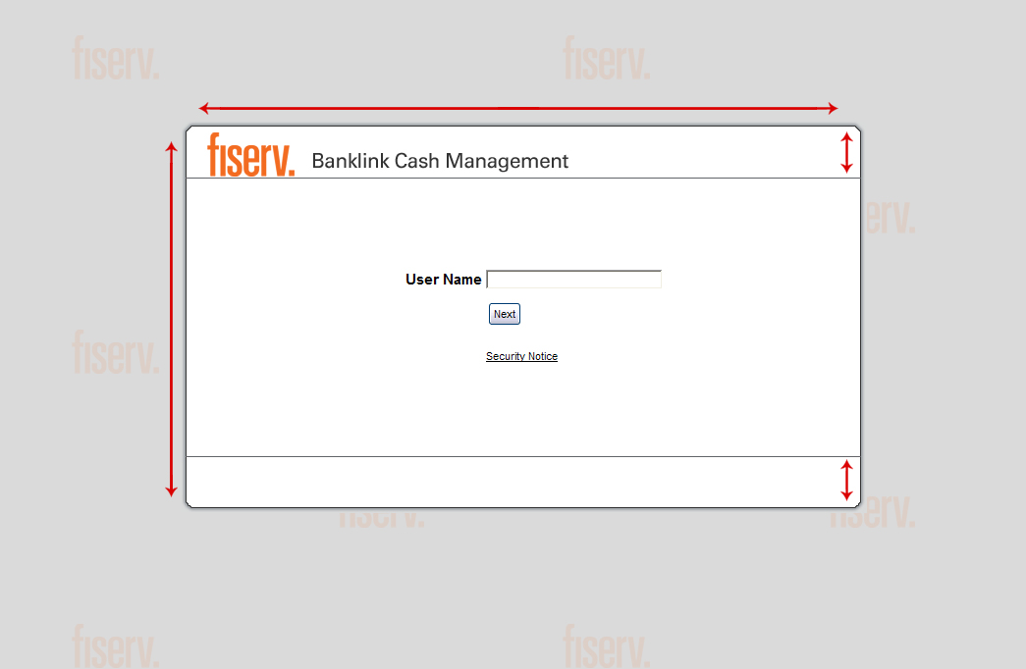

Login Dialog Box
700 pixels

60 pixels

400 pixels

60 pixels

Your product name and logo may be positioned anywhere across the top, bottom and left-hand side of the Dialog Box. The logo or product name must not exceed 60 pixels in height.

When determining a color or graphic for the dialog box, consider choosing a light or opaque color or image for optimal text legibility. The default font color for this screen is black.

Login Screen Background options include a solid color, a pattern or watermark. The watermark (like the one depicted above) or pattern will tile seamlessly in the background to create a wallpaper –like effect.

Upon initial login to the product, users are guided through a series of registration and setup screens. To maintain uniform branding, these subsequent screens will mirror the look and feel of the login screen.

IMAGE SPECS
Login Screen Dialog Box  Image Size: 700pix x 400pix  Logo Height: 60 pix  File format: *.gif | Login Screen Background  Image Size: 250pix x 150pix  File format: *.jpg | Watermark/Pattern  Image Size: 60pix x 60pix  Use: Tiled  File format: *.jpg

BRANDING WORKSHEET – LOGIN SCREEN
Select one login screen background option:

I would like a solid background  Background color*: DDE6F4 | I would like a watermark/pattern background  Custom image included: YES/ NO  If “No”, create custom image: YES / NO  Desired background color*:
* PMS, Hex or RGB values

- Home Page

The following image represents the available branding areas of the homepage. These areas include the header and header background, footer, info panes, and home page background.
Header 668 pixels
Header Background
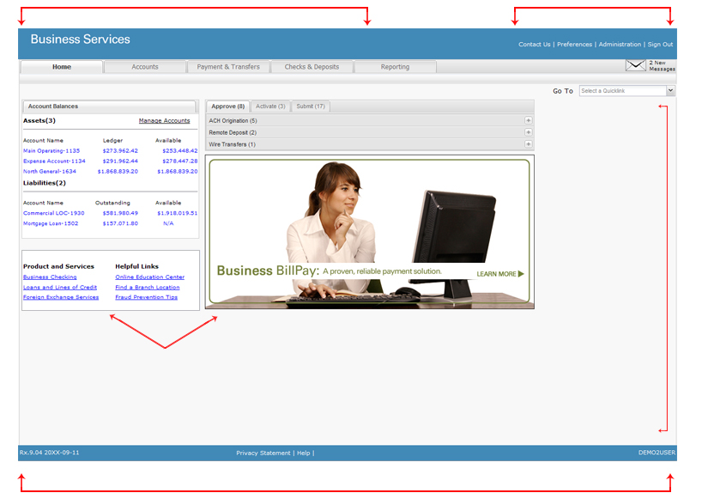

Background

Info Panes

Footer

The header hosts your financial intuition’s logo and product name. The header is the most visible branding touch point available – it’s a static image that appears on every screen of the product.

Header options include a solid color or gradient. The color or gradient selected for the banner graphic will be applied to the header background. The footer color may be set independently of the header and header background areas.

The main display area of the home page features two information panes. You may customize either info pane for a variety of purposes, such as promoting a new product or service, posting a welcome message or linking to your website. These panes support text, hyperlinks and images. Please refer to the specifications in the Premium Style Guide if you are interested in applying images to your site. You may stage and save up to five info panes as either text or images -- two of which may be used at any one time. The panes are updated and maintained via the Back Office system.

The home page background may be changed to include a solid color, pattern or watermark. This image will tile seamlessly in the background to create a wallpaper effect. Consider legibility and user experience when deciding on a color or pattern. The default backrgound color is white.

IMAGE SPECS
Home Page Background  Image Size: 250pix x 150pix  Use: Tiled  File Format: *.jpg  Small Info Pane (Left Pane)  Image Size: 75pix x 345pix  Use: text and hyperlinks | Header  Image Size: 668pix x 60pix  Text: No text past 375 pixels  Use: Solid to transparent  File Format: *.gif  Large Info Pane (Right Pane)  Image Size: 300 pix x 640pix  Use: text, hyperlinks and images

BRANDING WORKSHEET – HOME PAGE
Select one header background option:
I would like a solid background  Header color*: FFFFFF | I would like a gradient  Gradate from: to *
Select one home page background option:

I would like a solid background  Background color*: FFFFFF | I would like a watermark/pattern background  Same as Login Background: YES / NO  If “No”, is new image included? YES / NO  If “No”, create custom image: YES / NO  Desired Background Color*:
Define your footer color.

Same as header color: YES / NO

If “No”, define footer color*: 0041AD

* PMS, Hex or RGB values

- Main Application Menu Tabs

The following image represents the main application menu tabs. The tab colors are themeable and may be modified to match your desired color scheme. The menu tabs remain visible at all times for easy navigation.
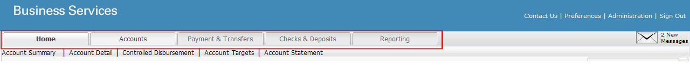

To change the look and feel of the homepage, choose from a library of 10 available menu tab colors. Your menu color selections are represented below:
Active menu tabs will take on the characteristic of the “menu” color, while the inactive tabs and navigation will pull characteristics from “navigation.”
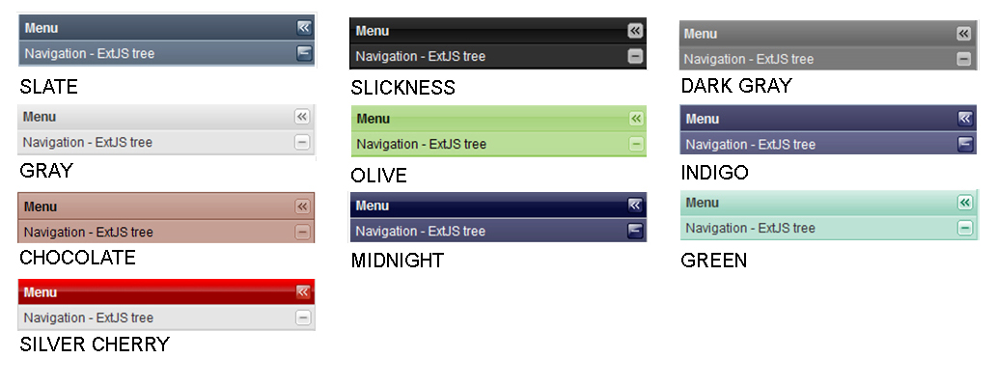

The chosen color theme will apply to the panes on the homepage as well as to the screen areas that display when a user selects from his general task window (e.g., Approve, Activate and Submit tabs).
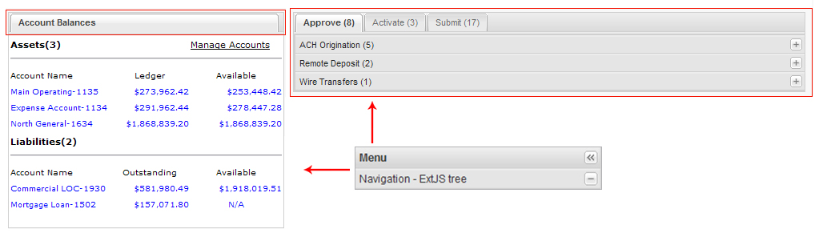

BRANDING WORKSHEET – MENU TABS
Select your menu tab color from the drop-down list:
Menu Tab selection: ▼ *

*Double-click in the gray box to activate the drop-down menu.

- Even Report Lines

As your customers generate more transactions, create more payments or scan more checks, the more important it becomes to view, track and report activity.

To improve legibility and presentation, we offer the option to brand the color of the Even Report Lines. Consider selecting an opaque color for this piece.

The default report line color is gray (#E6E7E8). The default font color is black.

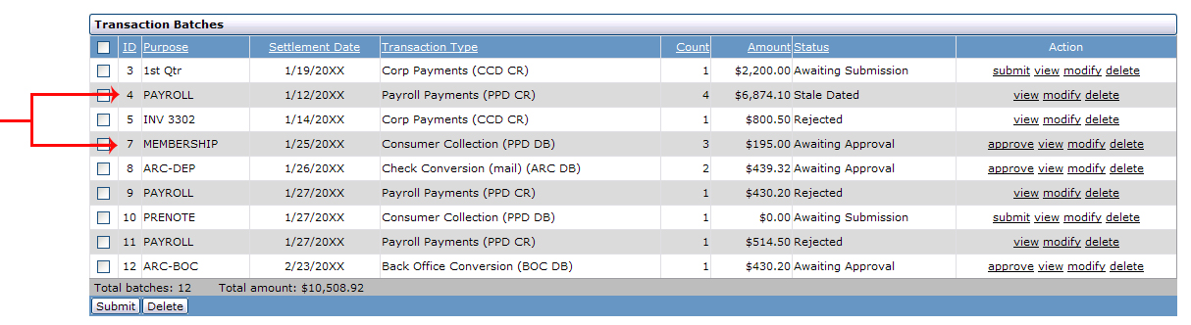
Even
Report
Lines

BRANDING WORKSHEET – REPORT LINES & FONT
Define your even report line color: | Define your font face:
Report line color*: DDE6F4 | Font face: ▼ *
* PMS, Hex or RGB values | *Double-click in the gray box to activate the drop-down menu.

- Fonts

Fiserv recommends the use of sans-serif fonts such as Arial, Verdana or Tahoma. These fonts are universal and represent good, clean type for the web. The default point size is 8 for all screens

- File Format & Size

Fiserv accepts graphics in GIF or JPEG format. We cannot accept any other files for branding purposes at this time. Follow the specifications in this guide to create your graphics.

GIF images should have their color palettes lowered to the lowest possible number of colors that maintains reasonable image quality while taking file size and download time into consideration.

JPEG images should have image quality/compression set to “medium” or lower to reduce the file size, while taking image quality into consideration.

- Submission Materials

If you’d prefer to have a Fiserv Branding Specialist brand your product for you, please submit the following: financial institution logo, product name, chosen URL, corporate color palette or completed style guide worksheets.

All source images should be submitted as Photoshop (.psd) or Illustrator (.eps) files with a minimum resolution of 300dpi.

Fiserv will provide proofs of the branded website to those financial institutions that request it.

- Timeframe

Fiserv will deliver your branded website within 14 business days, if all the branding files are received in the proper format.

You and your Fiserv Representative will be notified when the site is complete. You may make changes to your site up to one month before your live date.

- Contacts

Do you have a question? Need help creating a graphic? Your Fiserv Branding Specialist is happy to assist you.

Contact | Contact
Branding Specialist | Branding Specialist
Elizabeth Rottman | Olga Zgutowicz
212-419-3017 | 212-419-3046
elizabeth.rottman@fiserv.com | olga.zgutowicz@fiserv.com
General branding inquiries: branding@fiserv.com

